**THE TRAGEDY OF FLIGHT A COMPREHENSIVE CRASH ANALYSIS**

**Project Report**

*Submitted by*

**Reetchithaa P V 20UPH1765**

**Ruthradevi A 20UPH1766**

**Priyanka S 20UPH1764**



DEPARTMENT OF PHYSISCS

**PADMAVANI ARTS AND SCIENCE COLLEGE FOR WOMEN**

**Salem-636011**

**April 2023**

Project Topics

1. INTRODUCTION
   1. Overview
   2. Purpose
2. Problem Definition & Design Thinking
   1. Empthy Map
   2. Ideation & brainstorming Map
3. Result
4. Advantages and Dis Advantages
5. Application
6. Conclusion
7. Future Scope
8. Appendix

A.Scorce code

1. INTRODUCTION
   1. Overview

An airplane crash analysis is a The investigation should include the gathering, recording and analysis of all available information; the issuance of safety recommendations, if appropriate; the determination of the causes, if possible; and the completion of a final report.

* 1. Purpose

An airplane crash analysis is a detailed investigation into the causes of an aviation accident. The goal of an airplane crash analysis is to identify any factors that contributed to the accident, with the ultimate goal of improving safety and preventing future accidents. The process of conducting an airplane crash analysis typically involves the collection and analysis of a wide range of data, including information about the aircraft and its systems, the operators, and any other relevant factors. This data is typically collected from Kaggle. Once the data has been collected, it is analysed through tableau, to identify any potential causes of the accident. The results of an airplane crash analysis are typically published in a report, which may include recommendations for improving safety and preventing similar accidents in the future. These recommendations may be implemented by the relevant authorities or industry organizations.

1. Problem Definition & Design Thinking

2.1 Empthy Map

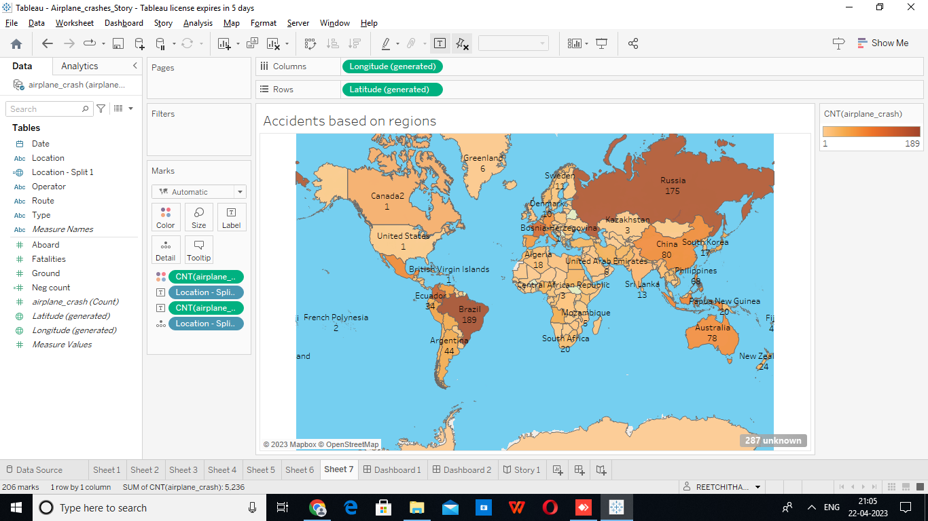

2.2 Ideation & brainstorming Map

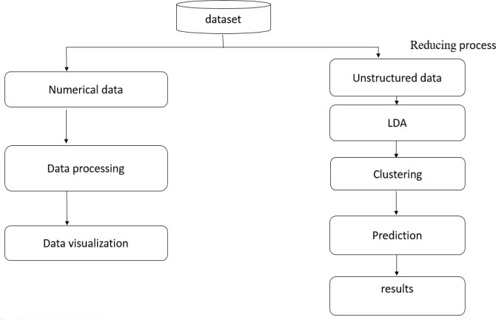

1. **Result**

**Sheet 1** - Comparing Aboard vs fatalities vs Ground

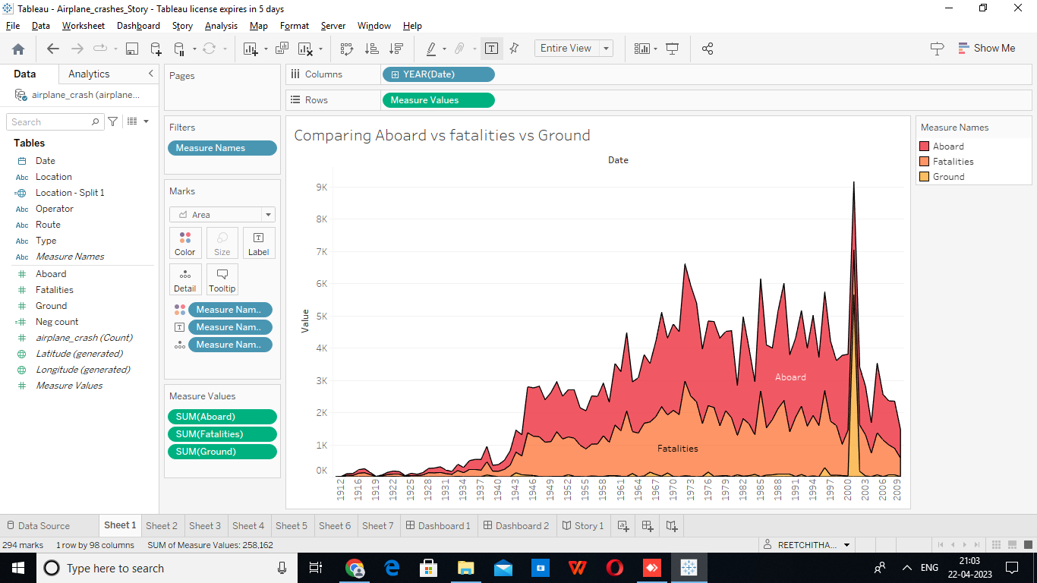

**Sheet 2** - Max accidents based on years

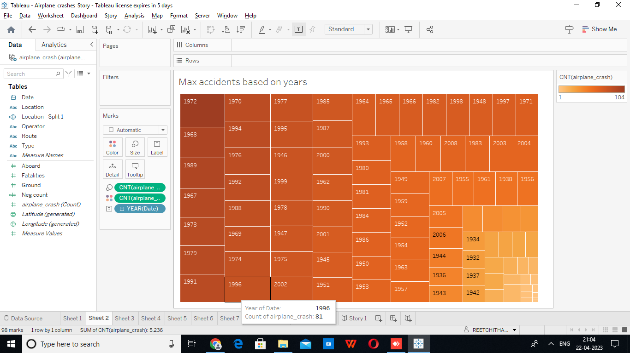

**Sheet 3** - Accident happened in 1972 (Max Accident) based on months

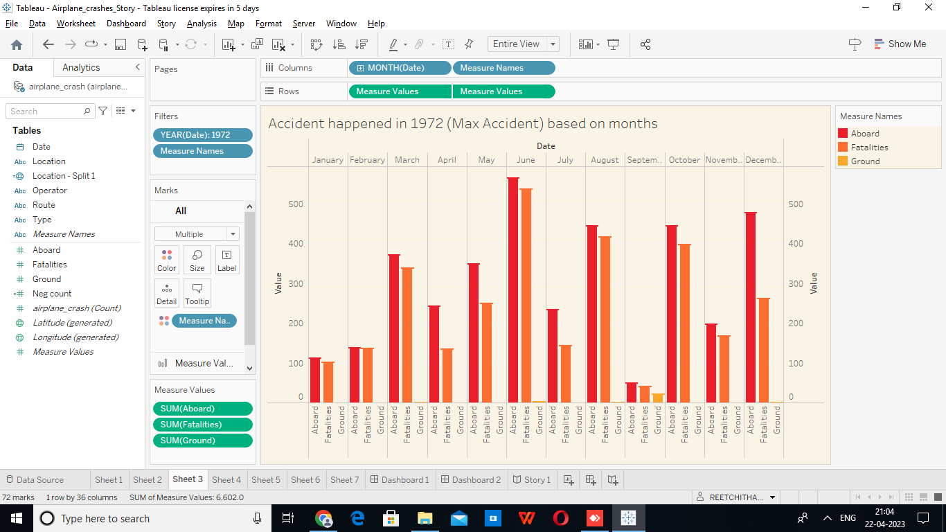

**Sheet 4** - Highest No.of .accident happened by operators

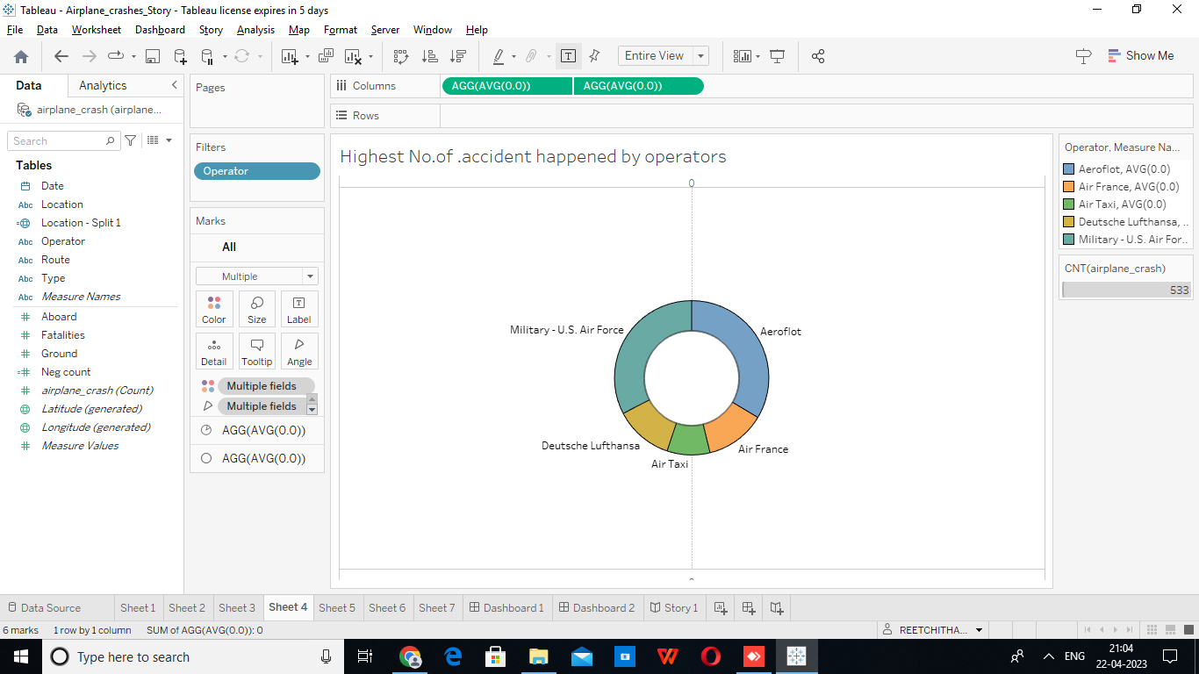

**Sheet 5** - Top 10 Location which had more accidents

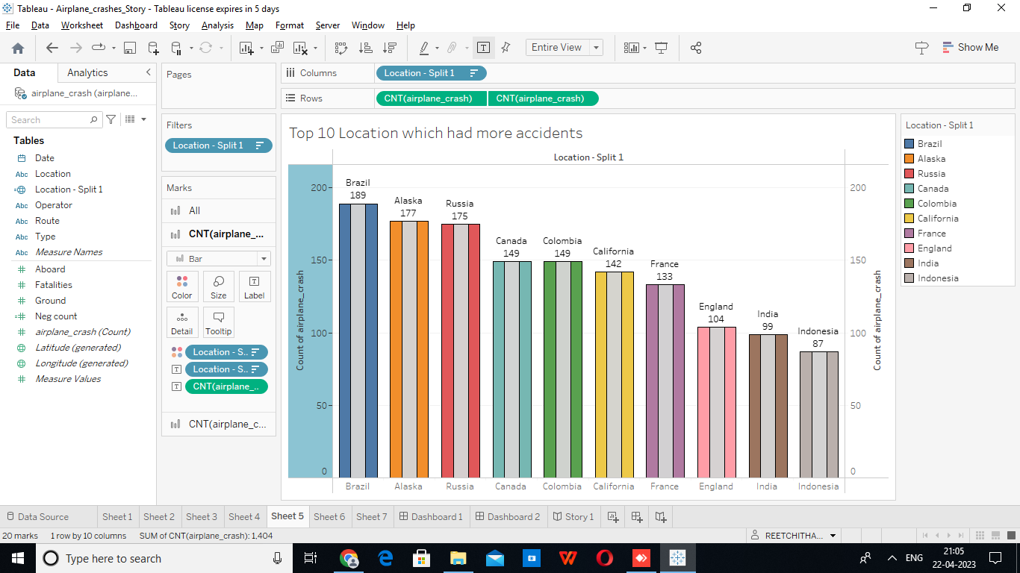

**Sheet 6** - Top 3 flights which have max accident history

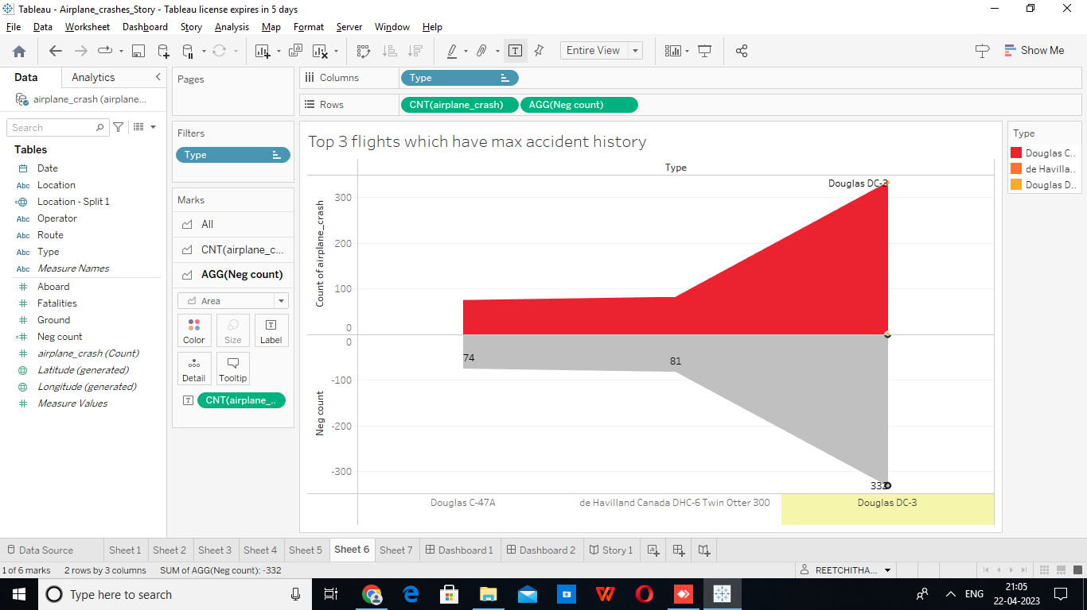

**Sheet 7** - Accidents based on regions



**Dashboard 1:**

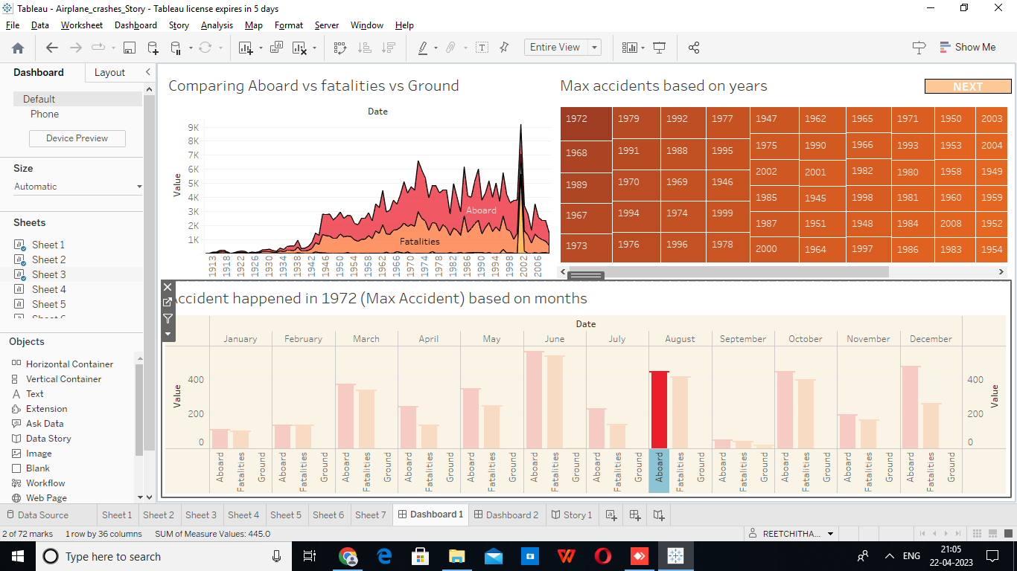

**Dashboard 2:**

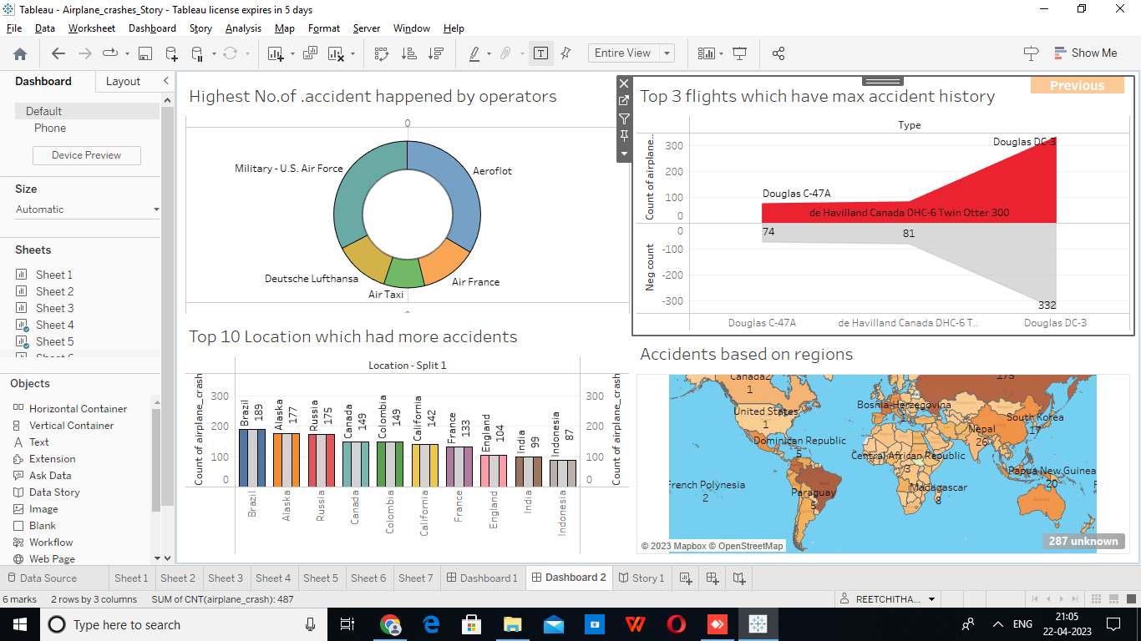

**Story :**

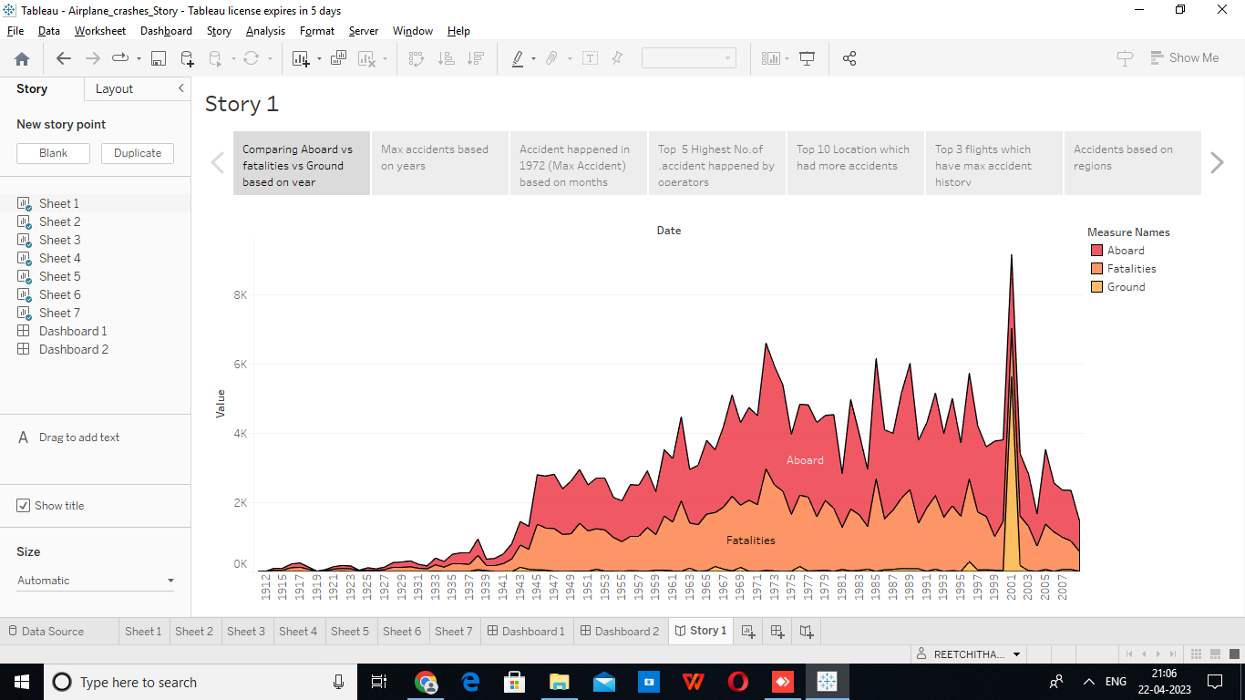

1. Advantages and Dis Advantages

4.1 Advantages

1. Ability to meet short deadlines.

2. Faster project execution.

3. Get the project back on track or back on schedule

4.2 Disadvantages

1. Increased risk.
2. It may require re-work.
3. Not suitable for all the project tasks.
4. Project cost increases in the case of re-work.

**5.Application or Website Screenshots :**

**About Project:**

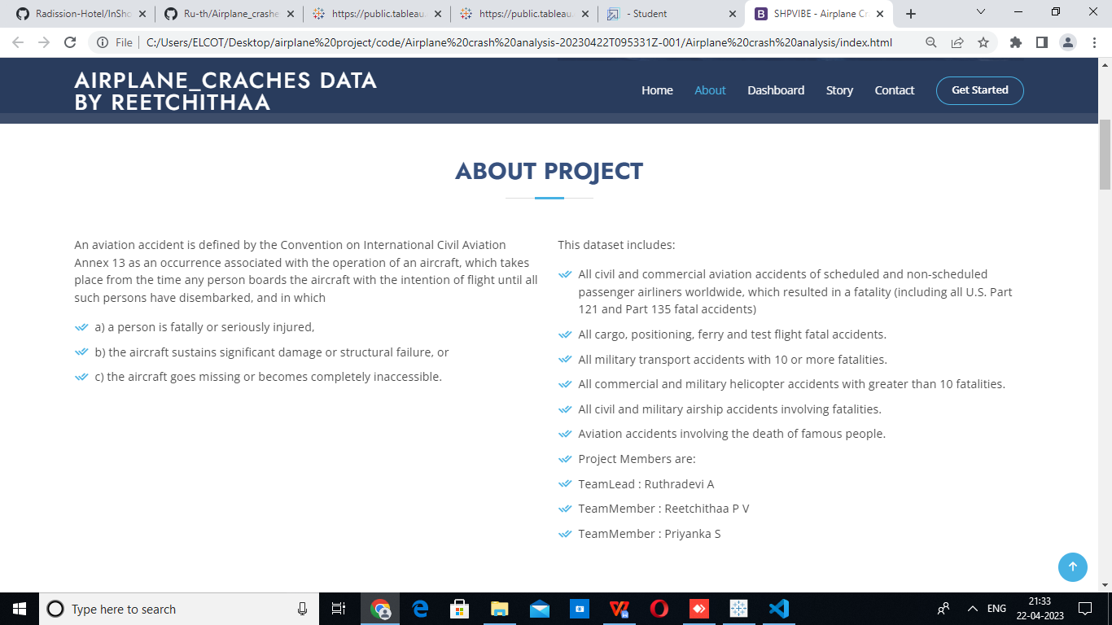

**Web_Dashboard**

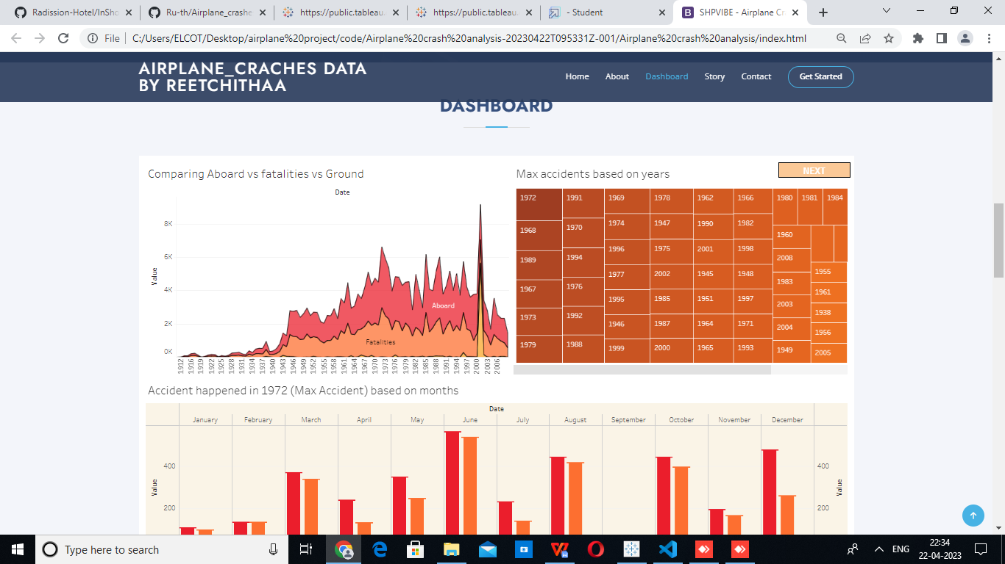

**Web_Story**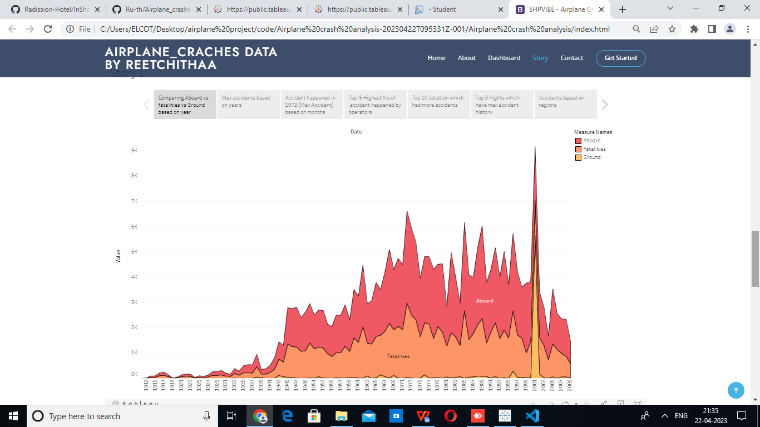

**Web_contact**

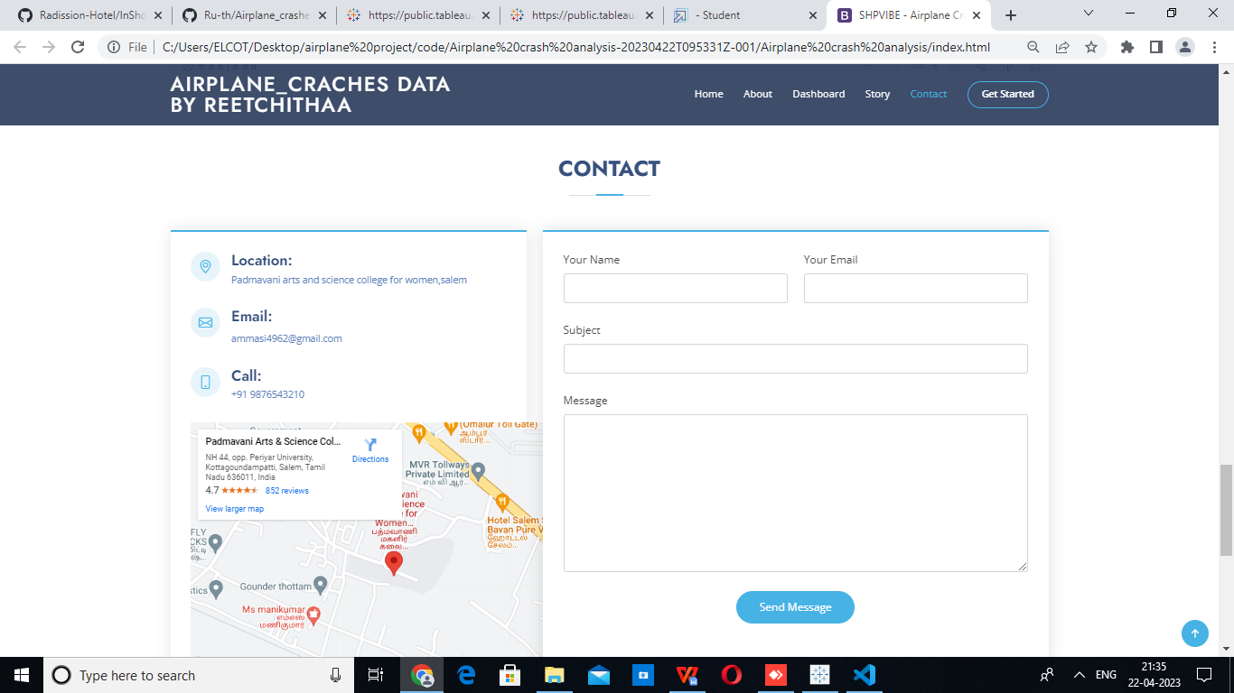

1. **Conclusion**

Safety is the main concern during air travel, because small careless mistakes also can create very critical situations for Aircraft operators. Safe aircraft operation is possible by proper understanding between pilots, crew members and operators. Also to achieve this, the excess of human workloads must be minimized in any work environments by following the implemented systems of the Airworthiness authorities. This study presented the details about the accident causes and safety techniques to reduce the causes. In this paper the past accident history of Indian aircraft industries has been considered. When compared to the other countries, the numbers of accidents in India are very less only. But human lives are directly involved in the accidents. So, accident prevention methods must be strictly followed by aircraft operators and the safety management system will be implemented in all aircraft industries for safe aircraft operations.

1. **Future scope**

The system is able to predict whether the airplane will be be “safe” or not. As a result, the delays of every airplane can also be predicted. The period after which an airplane has to go under the maintenance stage can also be included with the system. Hence, the system will be the one stop destination to check the flight delays, airplane crashes and the period after which the flight should undergo the maintenance phase.

1. Appendix
2. Source code

<!DOCTYPE html>

<html lang="en">

<head>

  <meta charset="utf-8">

  <meta content="width=device-width, initial-scale=1.0" name="viewport">

  <title>SHPVIBE - Airplane Crash</title>

  <meta content="" name="description">

  <meta content="" name="keywords">

  <!-- Favicons -->

  <link href="assets/img/favicon.png" rel="icon">

  <link href="assets/img/apple-touch-icon.png" rel="apple-touch-icon">

  <!-- Google Fonts -->

  <link href="https://fonts.googleapis.com/css?family=Open+Sans:300,300i,400,400i,600,600i,700,700i|Jost:300,300i,400,400i,500,500i,600,600i,700,700i|Poppins:300,300i,400,400i,500,500i,600,600i,700,700i" rel="stylesheet">

  <!-- Vendor CSS Files -->

  <link href="assets/vendor/aos/aos.css" rel="stylesheet">

  <link href="assets/vendor/bootstrap/css/bootstrap.min.css" rel="stylesheet">

  <link href="assets/vendor/bootstrap-icons/bootstrap-icons.css" rel="stylesheet">

  <link href="assets/vendor/boxicons/css/boxicons.min.css" rel="stylesheet">

  <link href="assets/vendor/glightbox/css/glightbox.min.css" rel="stylesheet">

  <link href="assets/vendor/remixicon/remixicon.css" rel="stylesheet">

  <link href="assets/vendor/swiper/swiper-bundle.min.css" rel="stylesheet">

  <!-- Template Main CSS File -->

  <link href="assets/css/style.css" rel="stylesheet">

  <!-- =======================================================

  * Template Name: Arsha - v4.9.1

  * Template URL: https://bootstrapmade.com/arsha-free-bootstrap-html-template-corporate/

  * Author: BootstrapMade.com

  * License: https://bootstrapmade.com/license/

  ======================================================== -->

</head>

<body>

  <!-- ======= Header ======= -->

  <header id="header" class="fixed-top ">

    <div class="container d-flex align-items-center">

      <h1 class="logo me-auto"><a href="index.html">Airplane_Craches Data <br>by Reetchithaa</br></a></h1>

      <!-- Uncomment below if you prefer to use an image logo -->

      <!-- <a href="index.html" class="logo me-auto"><img src="assets/img/logo.png" alt="" class="img-fluid"></a>-->

      <nav id="navbar" class="navbar">

        <ul>

          <li><a class="nav-link scrollto active" href="#hero">Home</a></li>

          <li><a class="nav-link scrollto" href="#about">About</a></li>

          <li><a class="nav-link scrollto" href="#team">Dashboard</a></li>

          <li><a class="nav-link scrollto" href="#pricing">Story</a></li>

          <li><a class="nav-link scrollto" href="#contact">Contact</a></li>

          <li><a class="getstarted scrollto" href="#about">Get Started</a></li>

        </ul>

        <i class="bi bi-list mobile-nav-toggle"></i>

      </nav><!-- .navbar -->

    </div>

  </header><!-- End Header -->

  <!-- ======= Hero Section ======= -->

  <section id="hero" class="d-flex align-items-center">

    <div class="container">

      <div class="row">

        <div class="col-lg-6 d-flex flex-column justify-content-center pt-4 pt-lg-0 order-2 order-lg-1" data-aos="fade-up" data-aos-delay="200">

          <h1>Airplane Crash analysis</h1>

          <h2>Airplane Crashes and Fatalities Since 1908</h2>

          <div class="d-flex justify-content-center justify-content-lg-start">

            <a href="#about" class="btn-get-started scrollto">Get Started</a>

            <a href="https://www.youtube.com/@thesmartbridge/videos" class="glightbox btn-watch-video"><i class="bi bi-play-circle"></i><span>Watch Video</span></a>

          </div>

        </div>

        <div class="col-lg-6 order-1 order-lg-2 hero-img" data-aos="zoom-in" data-aos-delay="200">

          <img src="assets/img/a1.jpg" class="img-fluid animated" alt="">

        </div>

      </div>

    </div>

  </section><!-- End Hero -->

  <main id="main">

        <!-- ======= About Us Section ======= -->

    <section id="about" class="about">

      <div class="container" data-aos="fade-up">

        <div class="section-title">

          <h2>About Project</h2>

        </div>

        <div class="row content">

          <div class="col-lg-6">

            <p>

              An aviation accident is defined by the Convention on International Civil Aviation Annex 13 as an occurrence associated with the operation of an aircraft, which takes place from the time any person boards the aircraft with the intention of flight until all such persons have disembarked, and in which

            </p>

            <ul>

              <li><i class="ri-check-double-line"></i> a) a person is fatally or seriously injured, </li>

              <li><i class="ri-check-double-line"></i> b) the aircraft sustains significant damage or structural failure, or </li>

              <li><i class="ri-check-double-line"></i> c) the aircraft goes missing or becomes completely inaccessible.</li>

            </ul>

          </div>

          <div class="col-lg-6 pt-4 pt-lg-0">

            <p>

              This dataset includes:

            <ul>

              <li><i class="ri-check-double-line"></i> All civil and commercial aviation accidents of scheduled and non-scheduled passenger airliners worldwide, which resulted in a fatality (including all U.S. Part 121 and Part 135 fatal accidents)</li>

              <li><i class="ri-check-double-line"></i> All cargo, positioning, ferry and test flight fatal accidents.</li>

              <li><i class="ri-check-double-line"></i> All military transport accidents with 10 or more fatalities.</li>

              <li><i class="ri-check-double-line"></i> All commercial and military helicopter accidents with greater than 10 fatalities.</li>

              <li><i class="ri-check-double-line"></i> All civil and military airship accidents involving fatalities.</li>

              <li><i class="ri-check-double-line"></i> Aviation accidents involving the death of famous people.</li>

              <li><i class="ri-check-double-line"></i> Project Members are:</li>

              <li><i class="ri-check-double-line"></i> TeamLead   : Ruthradevi A</li>

              <li><i class="ri-check-double-line"></i> TeamMember : Reetchithaa P V</li>

              <li><i class="ri-check-double-line"></i> TeamMember : Priyanka S</li>

              </ul>

            </p>

             </div>

        </div>

      </div>

    </section><!-- End About Us Section -->

    <!-- ======= Cta Section ======= -->

    <section id="cta" class="cta">

      <div class="container" data-aos="zoom-in">

        <div class="row">

          <div class="col-lg-9 text-center text-lg-start">

            <h3>Call To Action</h3>

            </div>

          <div class="col-lg-3 cta-btn-container text-center">

            <a class="cta-btn align-middle" href="#">Call To Action</a>

          </div>

        </div>

      </div>

    </section><!-- End Cta Section -->

    <!-- ======= Team Section ======= -->

    <section id="team" class="team section-bg">

      <div class="container" data-aos="fade-up">

        <div class="section-title">

          <h2>Dashboard</h2>

           </div>

           <div class='tableauPlaceholder' id='viz1682200042666' style='position: relative'><noscript><a href='#'><img alt='Dashboard 1 ' src='https:&#47;&#47;public.tableau.com&#47;static&#47;images&#47;Ai&#47;Airplane_crashes_Dashborad&#47;Dashboard1&#47;1_rss.png' style='border: none' /></a></noscript><object class='tableauViz'  style='display:none;'><param name='host_url' value='https%3A%2F%2Fpublic.tableau.com%2F' /> <param name='embed_code_version' value='3' /> <param name='site_root' value='' /><param name='name' value='Airplane_crashes_Dashborad&#47;Dashboard1' /><param name='tabs' value='no' /><param name='toolbar' value='yes' /><param name='static_image' value='https:&#47;&#47;public.tableau.com&#47;static&#47;images&#47;Ai&#47;Airplane_crashes_Dashborad&#47;Dashboard1&#47;1.png' /> <param name='animate_transition' value='yes' /><param name='display_static_image' value='yes' /><param name='display_spinner' value='yes' /><param name='display_overlay' value='yes' /><param name='display_count' value='yes' /><param name='language' value='en-US' /><param name='filter' value='publish=yes' /></object></div>                <script type='text/javascript'>                    var divElement = document.getElementById('viz1682200042666');                    var vizElement = divElement.getElementsByTagName('object')[0];                    if ( divElement.offsetWidth > 800 ) { vizElement.style.width='100%';vizElement.style.height=(divElement.offsetWidth*0.75)+'px';} else if ( divElement.offsetWidth > 500 ) { vizElement.style.width='100%';vizElement.style.height=(divElement.offsetWidth*0.75)+'px';} else { vizElement.style.width='100%';vizElement.style.height='977px';}                     var scriptElement = document.createElement('script');                    scriptElement.src = 'https://public.tableau.com/javascripts/api/viz_v1.js';                    vizElement.parentNode.insertBefore(scriptElement, vizElement);                </script>

      </div>

    </section><!-- End Team Section -->

    <!-- ======= Pricing Section ======= -->

    <section id="pricing" class="pricing">

      <div class="container" data-aos="fade-up">

        <div class="section-title">

          <h2>Story</h2>

          </div>

          <div class='tableauPlaceholder' id='viz1682200333849' style='position: relative'><noscript><a href='#'><img alt='Story 1 ' src='https:&#47;&#47;public.tableau.com&#47;static&#47;images&#47;Ai&#47;Airplane_crashes_Story&#47;Story1&#47;1_rss.png' style='border: none' /></a></noscript><object class='tableauViz'  style='display:none;'><param name='host_url' value='https%3A%2F%2Fpublic.tableau.com%2F' /> <param name='embed_code_version' value='3' /> <param name='site_root' value='' /><param name='name' value='Airplane_crashes_Story&#47;Story1' /><param name='tabs' value='no' /><param name='toolbar' value='yes' /><param name='static_image' value='https:&#47;&#47;public.tableau.com&#47;static&#47;images&#47;Ai&#47;Airplane_crashes_Story&#47;Story1&#47;1.png' /> <param name='animate_transition' value='yes' /><param name='display_static_image' value='yes' /><param name='display_spinner' value='yes' /><param name='display_overlay' value='yes' /><param name='display_count' value='yes' /><param name='language' value='en-US' /><param name='filter' value='publish=yes' /></object></div>                <script type='text/javascript'>                    var divElement = document.getElementById('viz1682200333849');                    var vizElement = divElement.getElementsByTagName('object')[0];                    vizElement.style.width='100%';vizElement.style.height=(divElement.offsetWidth*0.75)+'px';                    var scriptElement = document.createElement('script');                    scriptElement.src = 'https://public.tableau.com/javascripts/api/viz_v1.js';                    vizElement.parentNode.insertBefore(scriptElement, vizElement);                </script>

      </div>

    </section><!-- End Pricing Section -->

    <!-- ======= Contact Section ======= -->

    <section id="contact" class="contact">

      <div class="container" data-aos="fade-up">

        <div class="section-title">

          <h2>Contact</h2>

          </div>

        <div class="row">

          <div class="col-lg-5 d-flex align-items-stretch">

            <div class="info">

              <div class="address">

                <i class="bi bi-geo-alt"></i>

                <h4>Location:</h4>

                <p>Padmavani arts and science college for women,salem</p>

              </div>

              <div class="email">

                <i class="bi bi-envelope"></i>

                <h4>Email:</h4>

                <p>ammasi4962@gmail.com</p>

              </div>

              <div class="phone">

                <i class="bi bi-phone"></i>

                <h4>Call:</h4>

                <p>+91 9876543210</p>

              </div>

            <iframe src="https://www.google.com/maps/embed?pb=!1m18!1m12!1m3!1d3906.678819183847!2d78.0681063742353!3d11.717145541139892!2m3!1f0!2f0!3f0!3m2!1i1024!2i768!4f13.1!3m3!1m2!1s0x3babfa3202072c07%3A0x1d7638ba12d12c82!2sPadmavani%20Arts%20%26%20Science%20College%20for%20Women%2C%20Salem!5e0!3m2!1sen!2sus!4v1682205725696!5m2!1sen!2sus" width="600" height="450" style="border:0;" allowfullscreen="" loading="lazy" referrerpolicy="no-referrer-when-downgrade"></iframe>

            </div>

          </div>

          <div class="col-lg-7 mt-5 mt-lg-0 d-flex align-items-stretch">

            <form action="forms/contact.php" method="post" role="form" class="php-email-form">

              <div class="row">

                <div class="form-group col-md-6">

                  <label for="name">Your Name</label>

                  <input type="text" name="name" class="form-control" id="name" required>

                </div>

                <div class="form-group col-md-6">

                  <label for="name">Your Email</label>

                  <input type="email" class="form-control" name="email" id="email" required>

                </div>

              </div>

              <div class="form-group">

                <label for="name">Subject</label>

                <input type="text" class="form-control" name="subject" id="subject" required>

              </div>

              <div class="form-group">

                <label for="name">Message</label>

                <textarea class="form-control" name="message" rows="10" required></textarea>

              </div>

              <div class="my-3">

                <div class="loading">Loading</div>

                <div class="error-message"></div>

                <div class="sent-message">Your message has been sent. Thank you!</div>

              </div>

              <div class="text-center"><button type="submit">Send Message</button></div>

            </form>

          </div>

        </div>

      </div>

    </section><!-- End Contact Section -->

  </main><!-- End #main -->

  <!-- ======= Footer ======= -->

  <footer id="footer">

    <div class="footer-newsletter">

      <div class="container">

        <div class="row justify-content-center">

          <div class="col-lg-6">

            <h4>Join Our Newsletter</h4>

            <form action="" method="post">

              <input type="email" name="email"><input type="submit" value="Subscribe">

            </form>

          </div>

        </div>

      </div>

    </div>

    <div class="footer-top">

      <div class="container">

        <div class="row">

          <div class="col-lg-3 col-md-6 footer-links">

            <h4>Useful Links</h4>

            <ul>

              <li><i class="bx bx-chevron-right"></i> <a href="#hero">Home</a></li>

              <li><i class="bx bx-chevron-right"></i> <a href="#about">About</a></li>

              <li><i class="bx bx-chevron-right"></i> <a href="#portfolio">Charts</a></li>

              <li><i class="bx bx-chevron-right"></i> <a href="#team">Dashboard</a></li>

              <li><i class="bx bx-chevron-right"></i> <a href="#pricing">Story</a></li>

            </ul>

          </div>

          <div class="col-lg-3 col-md-6 footer-links">

            <h4></h4>

            <ul>

            </ul>

          </div>

          <div class="col-lg-3 col-md-6 footer-links">

            <h4></h4>

            <ul>

            </ul>

          </div>

          <div class="col-lg-3 col-md-6 footer-links">

            <h4>Our Social Networks</h4>

            <div class="social-links mt-3">

              <a href="https://www.linkedin.com/in/hariprabu741/" class="linkedin"><i class="bx bxl-linkedin"></i></a>

              <a href="#" class="twitter"><i class="bx bxl-twitter"></i></a>

              <a href="#" class="facebook"><i class="bx bxl-facebook"></i></a>

              <a href="#" class="instagram"><i class="bx bxl-instagram"></i></a>

              <a href="#" class="google-plus"><i class="bx bxl-skype"></i></a>

            </div>

          </div>

        </div>

      </div>

    </div>

    <div class="container footer-bottom clearfix">

      <div class="copyright">

        &copy; Copyright <strong><span>SHPVIBE</span></strong>. All Rights Reserved

      </div>

      <div class="credits">

        <!-- All the links in the footer should remain intact. -->

        <!-- You can delete the links only if you purchased the pro version. -->

        <!-- Licensing information: https://bootstrapmade.com/license/ -->

        <!-- Purchase the pro version with working PHP/AJAX contact form: https://bootstrapmade.com/arsha-free-bootstrap-html-template-corporate/ -->

        Designed by <a href="https://bootstrapmade.com/">SHPVIBE</a>

      </div>

    </div>

  </footer><!-- End Footer -->

  <div id="preloader"></div>

  <a href="#" class="back-to-top d-flex align-items-center justify-content-center"><i class="bi bi-arrow-up-short"></i></a>

  <!-- Vendor JS Files -->

  <script src="assets/vendor/aos/aos.js"></script>

  <script src="assets/vendor/bootstrap/js/bootstrap.bundle.min.js"></script>

  <script src="assets/vendor/glightbox/js/glightbox.min.js"></script>

  <script src="assets/vendor/isotope-layout/isotope.pkgd.min.js"></script>

  <script src="assets/vendor/swiper/swiper-bundle.min.js"></script>

  <script src="assets/vendor/waypoints/noframework.waypoints.js"></script>

  <script src="assets/vendor/php-email-form/validate.js"></script>

  <!-- Template Main JS File -->

  <script src="assets/js/main.js"></script>

</body>

</html>